Context Diagram: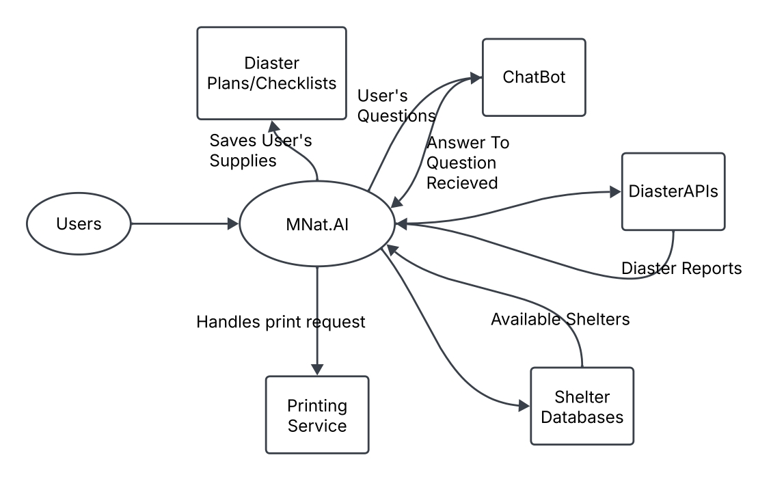

Level 0 Diagram:

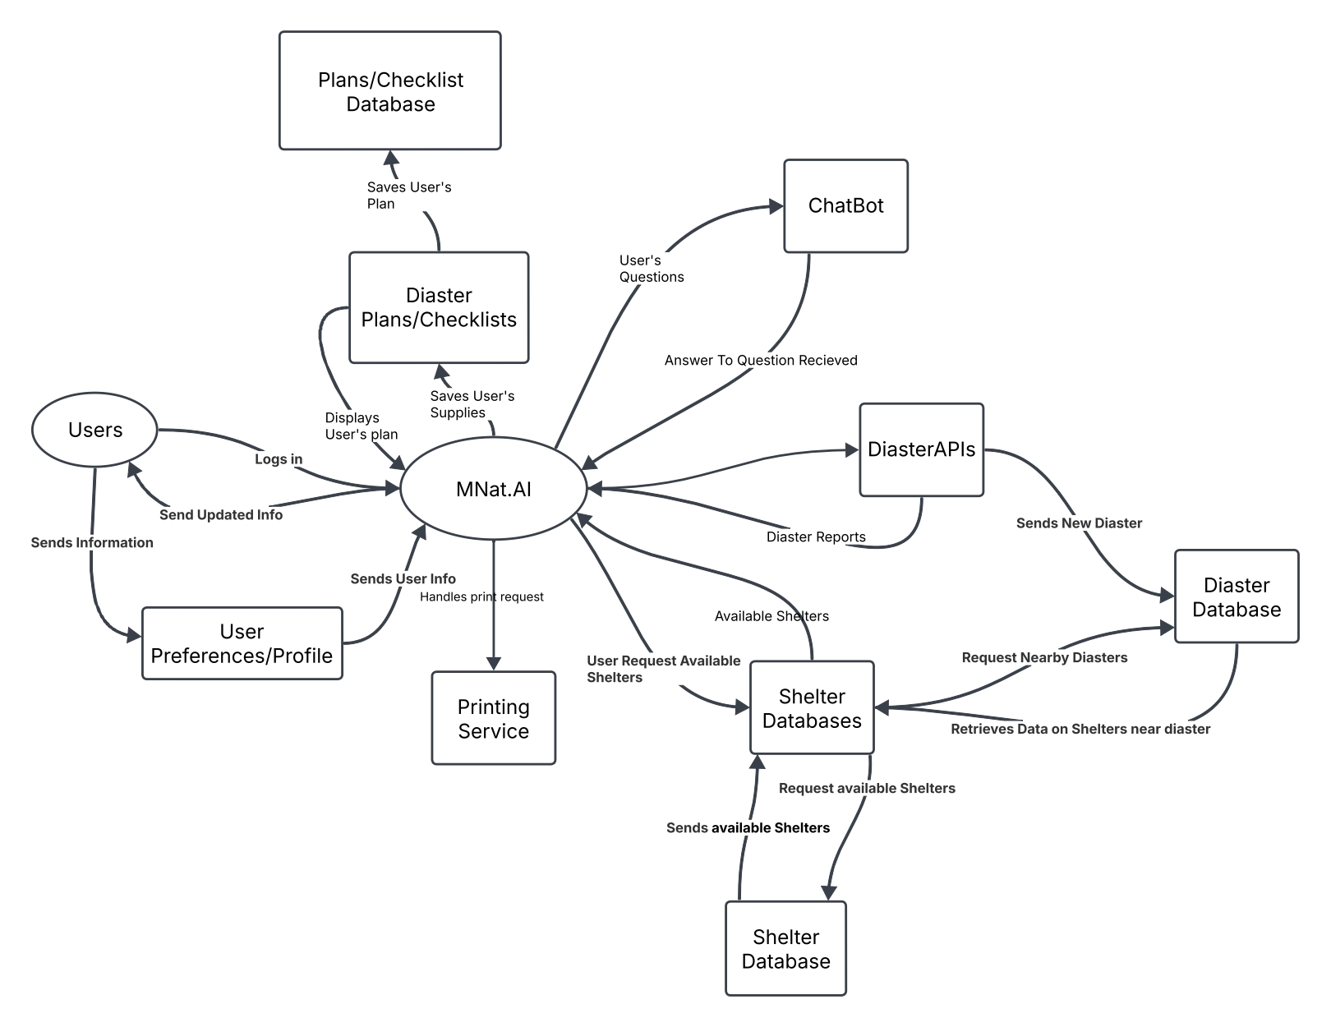

Level 1 Diagram (Saving User Info):

